A green breakthrough for the commercial and business sector: ComSos Project is here
The EU-funded project aims to install 25 high efficiency and zero emissions Solid Oxide Fuel Cell systems in the commercial and business sector

Worries about climate change, warmer average temperatures and international campaigns about environmental issues, from ocean’s plastic pollution to CO₂ emissions, have raised a new sensitivity on environment as a key factor for development. As a matter of fact, climate change is showing its negative effect on lifestyle and its impact on local economies due to extreme events like floodings, droughts, stormy and unpredictable weather. Thus, a new customer’s environmental sensitivity pushed to ask brands for more ethical choices. Environment is on top of the list and companies are more and more involved in marketing campaigns devoted to show how their products meet green requirements across the entire value chain, from raw material up to recycling at the end of the product’s lifecycle.
Environmental issues are therefore a marketing leverage to be used in advertising campaign supporting the product but also a compulsory requirement in many national legislation. The choice to look at green energy has recently taken a major role in both, innovation in production and advertising, underlining the impact of environmental issues as a contribution to C02 emissions and climate change reduction strategies. As a matter of fact, since 2015 mayor European and American brands like IKEA, Marks&Spencer, Walmart, ASDA have set a target of using 100% of renewables with positive effects on their business from a marketing and business point of view. Walmart, a major US brand, declared to have reached a 70 million kilowatt-hours (kWh) of renewable clean solar energy per year, which is the average consumption of 5400 homes.

Following the path of this green revolution, a group of EU companies and research centers have developed the ComSos - Commercial-scale SOFC systems – project that aims to bring the advantages of zero emissions and fuel cell technology to the commercial sector.
As a matter of fact, the HORIZON2020 EU funded project involves the demonstration of fuel-cell based energy solutions in real client environments, in cooperation with leading European system experts.
Through the project, manufacturers may take advantage in developing capacity for serial manufacturing, sales and marketing of Mini Fuel Cell Combined Heat and Power (Mini FC-CHP) products in the power ranges of 10-12 kW, 20-25 kW, and 50-60 kW. All manufacturers will validate new product segments in collaboration with the respective customers, confirm product performance, business case, size, and test in real life the distribution channel including maintenance and service. Based on findings related to the specific segments, the system will be suitable for volumes from few 10’s to several 1000 systems per year. As a matter of fact, the project aims at strengthening the European SOFC industry’s world-leading position for SOFC products in the range of 10- 60 kW.

The ComSos project will implement 25 SOFC technology-based power generation solutions around the world bringing the commercial sector to an unprecedented high efficiency and environmentally friendly approach to energy consumption.
Innovative, commercial and energy-efficient SOFC applications are thus emerging from the project which will provide clear evidence to the commercial sector, the building sector and the general public of the key advantages of SOFC systems: high electrical efficiency (up to 60%, the highest achievable among competitors), modularity and zero emissions to atmosphere (NO_{x}, SO_{x}, PM, VOC ...).

Moreover, for companies that are interested about this innovative green energy technology and want to learn more, ComSos website is updated with the latest project news, and a contact form to reach extra informations on how to join the Industrial Advisory Board in order to contribute to the project.
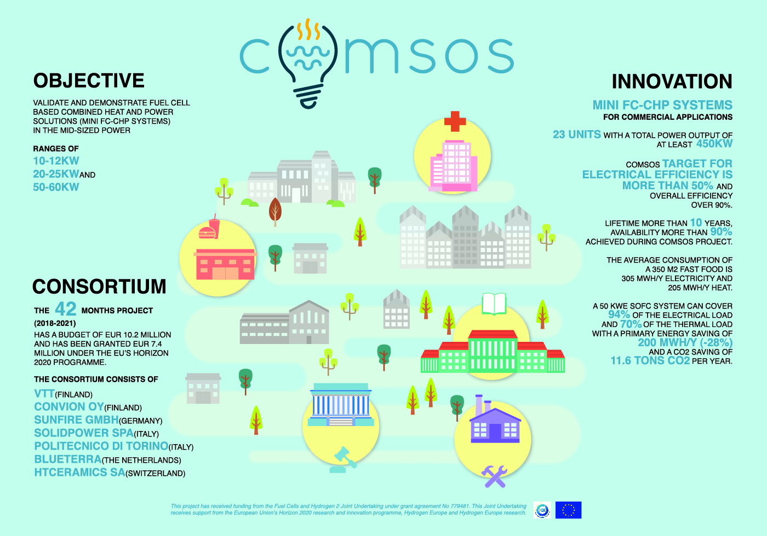

ComSos is a 42-months project (2018-2021) with a budget of EUR 10.2 million, granted EUR 7.4 million under the EU’s Horizon 2020 programme managed by FCH-JU.
The project, coordinated by VTT, includes the following partners: Convion Oy (Finland), Sunfire GmbH (Germany), SOLIDpower SpA (Italy), Politecnico di Torino (Italy), Blueterra (The Netherlands), HTceramics SA (Switzerland).

COMSOS has received funding from the Fuel Cells and Hydrogen 2 Joint Undertaking under grant agreement No 779481. This Joint Undertaking receives support from the European Union’s Horizon 2020 research and innovation programme, Hydrogen Europe and Hydrogen Europe research.

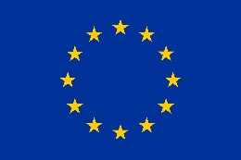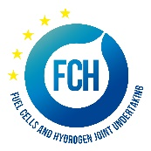

Contacts:
Website – www.comsos.eu
Email – comsos@polito.it
